EGN6133-Enterprise Engineering
Term Project
To-Be Model for a set of Sensormatic brand products from Tyco Fire & Security

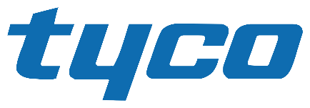 |  | INCLUDEPICTURE "http://www.tyco.com/uploads/logos/sensomatic.png" \* MERGEFORMATINET 

Contents
History and Overview 3
Key Dates in Sensormatic History 3
Corporate Mission 3
Values 3
Corporate Strategy 3
Roadmap 3
Product Lines 3
Project Scope 3
Bill of Materials (BOM) 3
Product Assembly 3
As-Is IDEF0 Functional Model 3
As-Is Object Model 3
As-Is Dynamic Model 3
To-Be IDEF0 Functional Model 3
To-Be Object Model 3
To-Be Dynamic Model 3
To-Be Organizational Chart 3
To-Be Organizational Structure 3

History and Overview
Sensormatic is in the business of the manufacture and sale of electronic article surveillance equipment. Our portfolio includes vital loss prevention and operational improvement technologies and solutions. Backed by more than 1,500 patents, the Sensormatic solutions portfolio is sold through ADT and authorized business partners around the world. From the front of the store through the entire retail supply chain, our products and services help keep losses lower—and profits higher.

Today, over 80 percent of world's top 200 retailers that use EAS rely on Sensormatic solutions, which include EAS, source-tagging, data analytics and in-store, item-level intelligence applications. Sensormatic forward-thinking solutions also include dual EAS-RFID technology that provides item-level security and visibility in an ever-changing retail environment.

Sensormatic is focused on operational improvements on the retail selling floor. Traditionally a loss prevention company, Sensormatic now helps retailers address their most significant form of loss—decreased sales due to inventory inaccuracies. Our family of item-level RFID solutions enables information accuracy that drives intelligence back into the supply chain by improving the integrity of the data at the item level. These products are designed to improve existing store operations, increase product availability and enhance the customer shopping experience. Retailers are recognizing that dual EAS/RFID functionality addresses both item-level security and item-level visibility to help prevent theft while improving the quality of item-level data.

Tyco International (NYSE: TYC) is a diversified, global company that provides vital products and services to customers in more than 60 countries. Tyco is a leading provider of security products and services, fire protection and detection products and services, valves and controls, and other industrial products. Tyco had 2007 revenues of more than $18 billion and has 118,000 employees worldwide.

Key Dates in Sensormatic History
- 1960: Sensormatic is established and incorporated in Florida.
- 1988: Sensormatic Electronics Corp. of Deerfield Beach announces buy-out of Allied-Signal Corp.
- 1995: Sensormatic signs up to sponsor 1996 Atlanta Olympic Games.
- 2000: Sensormatic signs up to sponsor 2002 Winter Olympic Games.
- 2001: Sensormatic is purchased by Tyco International Ltd.
- 2007: Tyco concludes a corporate separation that splits the company into three publicly independent companies: Covidien Ltd. (formerly Tyco Healthcare), Tyco Electronics Ltd. (now TE Connectivity Ltd.) and Tyco International Ltd. (formerly Tyco Fire & Security and Tyco Engineered Products & Services). Sensormatic becomes part of Tyco Fire & Security.
- 2012: Tyco International splits into three independently traded companies: The ADT Corporation, Tyco Fire and Security, and Pentair Ltd.

Corporate Mission
Tyco’s mission is to advance safety and security by finding smarter ways to save lives, improve businesses, and protect where people live and work.

Values
As part of the Tyco family of companies, Sensormatic Retail Solutions attracts, develops and promotes a diverse and inclusive work environment that reflects the global community. We have programs that foster diversity and inclusion and support Tyco's values of Integrity, Teamwork, Excellence, and Accountability.

Corporate Strategy
As a pure-play operating company, we will align our functional and business resources as one organization, dedicated to executing on that growth strategy. Each of our business units will also continue to have their own specific strategies and initiatives, depending on their unique market needs—and we will all be pulling in the same direction as one company.

Roadmap
The roadmap within Tyco Retail Solutions is to provide a retailer a fully integrated solution to problems facing brick and mortar operations. This is done by providing:

- Safety and Security Solutions
- Loss Prevention
- Inventory Intelligence
- Store Traffic Intelligence

The integration of these systems can provide a level of performance and security solutions matched in the market place.

Product Lines
Hard Tag Family  - Ultra•Tag® Platform  - SuperTag® III Family  - Alarming SuperTag®  - SuperTag® Visible Source Tag (VST)  - SuperTag® Ink  - Soft Tag  - Ultra*Gator®  - Ultra•Lock®  - Essentials Platform  - AMT-5000 Hard Tag Family  - AMT-3200 Hard Tag Family  - AMT-3210 Accessory Hard Tag  - AMT3220 Delicates Hard Tag  EAS Labels Family  - Ultra•Strip® III  - Ultra•Strip® III Insertable  - Ultra•Strip® III Microwavable  - Ultra•Strip® III Book Label  - Ultra•Strip® III Individual Label  - Ultra•Strip® III Low Profile  - Ultra•Strip® III Hang Tag  - Ultra•Strip® II Narrow  - Non-Deactivatable Label | EAS Detection System  - Pedestal Systems  - Discreet Systems  - Concealed Systems  - Detection Accessories  - Auxiliary Antennas  Label Deactivators  - ScanMax® Pro Family  - Other Deactivators and Activators  - Essentials Platform  Hard Tag Detachers  - AMD-3040 Hand-Held Detacher  - MK75I Hand Detacher  - MKD-400 Detacher  - AMK 1000/1010 Detacher  - MK75IZA Hand Detacher with Boot Deactivator  - AMD-1000 Detacher  - AMK 4200/4300 Detacher  - AMK-4100 Decoupler

Project Scope
The project scope will be limited to the following set of products. This product set is typical of that used to outfit a retail store.

- SuperTag® III
- Ultra•Strip® III Individual Label

Bill of Materials (BOM)

Bill of Materials
PART NAME | PART NUMBER | QTY / UNIT | COST / ORDER | ORDER QTY | COST / UNIT | MATERIAL | VENDOR
Label | LabelAssy |  | $274.95 | 5000 | $0.05
Formed plastic cavity | LabelCavity | 1 | $29.27 | 5000 | $0.0059 | RAW | The Best Project Material CO. LTD
Magnetostrictive material ribbon | MagRibbon | 2 | $13.90 | 5000 | $0.0056 | RAW | Rare Earth Alloys, LLC.
Bias material ribbon | BiasRib | 1 | $12.00 | 5000 | $0.0024 | RAW | Rare Earth Alloys, LLC.
Adhesive film backing | LabelAdhesiveFilm | 1 | $24.00 | 5000 | $0.0048 | RAW | The Best Project Material CO. LTD
 |  |  |  |  | $0.019 | Total
Hard tag | HardTagAssy |  | $631.80 | 1000 | $0.63
Top housing enclosure | TagTopHouse | 1 | $130.00 | 5000 | $0.0260 | RAW | Colorful Polymers International
Bottom housing enclosure | TagBotHouse | 1 | $120.00 | 5000 | $0.0240 | RAW | Colorful Polymers International
Magnetostrictive material ribbon | MagRibbon | 2 | $13.90 | 5000 | $0.0056 | RAW | Rare Earth Alloys, LLC.
Bias material ribbon | BiasRib | 1 | $12.00 | 5000 | $0.0024 | RAW | Rare Earth Alloys, LLC.
Pin locking spring | TagPinSpring | 1 | $412.10 | 5000 | $0.0824 | TRADING GOOD | Mega Machining Company
Security pin | TagSecurityPin | 1 | $340.20 | 5000 | $0.0680 | TRADING GOOD | Mega Machining Company
 |  |  |  |  | $0.21 | Total

Product Assembly

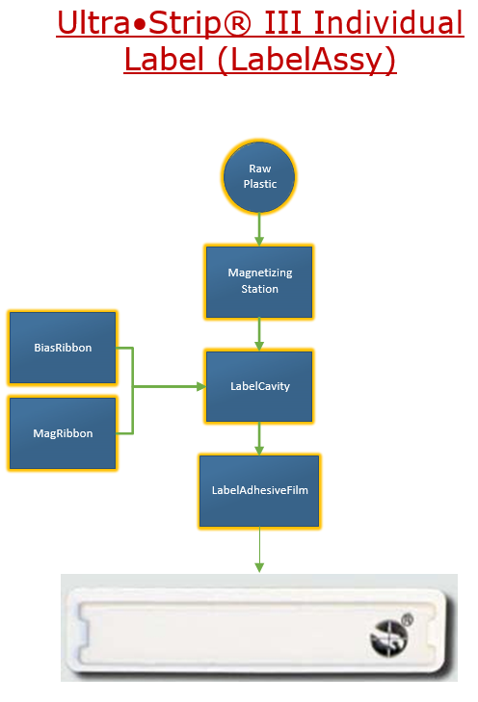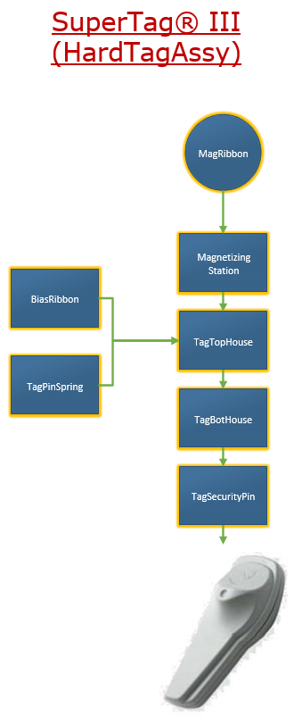

As-Is IDEF0 Functional Model

As-Is Object Model

As-Is Dynamic Model

To-Be IDEF0 Functional Model

To-Be Object Model

To-Be Dynamic Model

To-Be Organizational Chart

To-Be Organizational Structure

